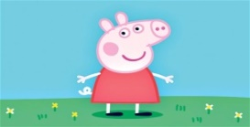

* *Smile-A-Mile Fun Bus*
* *Free Sausage Sizzle and Icy Poles*
* *Taminmin Library Fun Activities*
* *Peppa Pig*
* *Jumping Castles*
* *Face Painting*
* *Balloon Twisting and Magic*
* *Freestyle Fitness*
* *Two Seasons Events*
* *NAB AFL Auskick*
* *Neighbourhood Watch*

For more information please contact Jacinta at Smile-A-Mile Fun Bus & Toy Library Inc.

Email: toys@smileamile.org.au Phone: 89832009

*The Australian Government provides financial support for this Budget Based Funded Child Care Service under the Community Support Programme.*

***Proudly Sponsored by***

**Free Child Restraint Checks** 

***Smile-A-Mile invites you to come along and***

***Celebrate Children’s Week***

***“Children’s Right are Human Rights”***

**Lots of free children’s activities!**

**Village Green Humpty Doo**

**Thursday 29th October 2015**

**9:30am – 12:00pm**

***Children’s Week***